Table of Contents

BARAZA PAYROLL SYSTEM 3
Payroll Process Flow 4
Administrative Log-in 5
Control Panel 6
DEFINITIONS 6
PAY GROUPS 9
STATUTORY DEDUCTIONS 10
BANKS 12
EMAIL TEMPLATES 14
ENTRIES 15
EMPLOYEES 15
MONTHLY PAYROLL 19
REPORTS 28

BARAZA PAYROLL SYSTEM

As your organization grows, the demands on your operations ensure you hire human resources and pay them salaries based on their responsibilities and deliverables. Salaries may be fixed or based on performance or a combination of both.
As the number of variables grows each time you are processing salaries, the chances of errors creeping in increase. You need to keep a track of all your employee details, their attendance, overtime, performance linked incentives, leaves, expense reimbursements as well as various deductions mandated by labour and income tax laws.
Your salary calculations should be efficient enough to provision for any investments that your employees make and which entitle them to various tax exemptions provided by the Government.
The entire process becomes extremely cumbersome and any errors have serious implications in terms of interest and penalties for delayed statutory compliances as well low employee morale.
Enter Baraza Payroll System (BPS).
Below are key advantages that should be the key motivators for you to switch to Baraza Automated Payroll system, a professional and automated payroll system:
- Simplifies data entry, saves time and helps reduce errors.
- Processing payroll becomes fast and easy compared to manual systems; save on time and extra manpower costs.
- Employee Self-help tools help enhances productivity across the board; employees can view their pay slips, apply for reimbursements and declare investments without eating into your quality HR time.
- All payroll information remains in one location, giving you extreme control over your data.
- Uses predefined schemes to auto calculate all deductions related to labour laws and income tax, company overtime remuneration, deductions and advances, and ensure you meet all your statutory compliances.
- All government reporting becomes easy, such as filing mandatory deductions and filing returns accurately and on time.
- It is very user friendly, with a web interface accessible from any web browser.

High level of security at the server, database level, and the user interface level. Users get their own log-in accounts centrally managed, with which the can log into the system.
- Integrates and shares data with other systems such as Financial and HR systems in the Baraza Open Platform.

Payroll Process Flow

Administrative Log-in
The log-in interface for the system is very straight forward and simple, accessible from any web browser. Users log in with personal log-in accounts created at the administration level of the system
The system's configurations are accessible via the web or by running a Java application launcher.

The administrator logs in with their credentials and proceed to use the system.

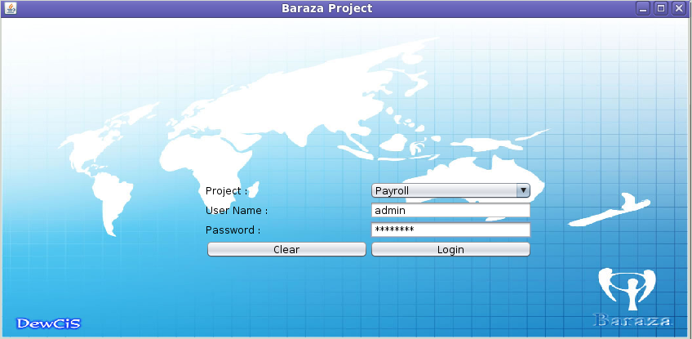

Once logged into the system, the admin is presented with an administrative interface with a wide range of system-wide configurable modules.

Administrative home screen

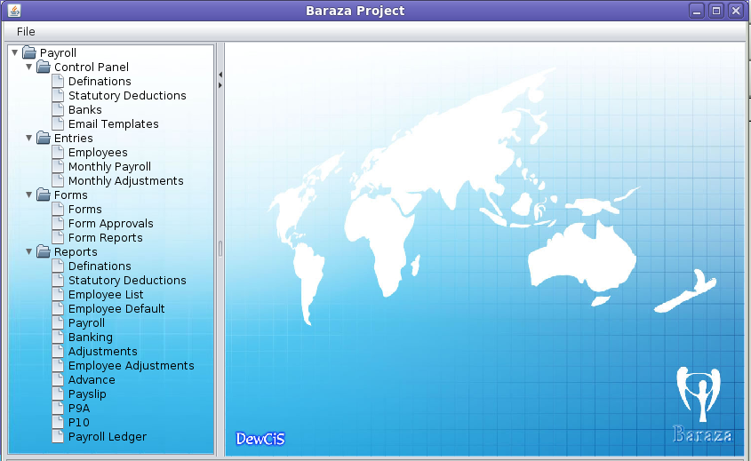

Control Panel
DEFINITIONS:
These are the different types of Allowances, Deductions, Expenses and Pay Groups accounted for. To create a new Allowance, Deduction or Expense;

- Click on the NEW button under Allowances, Deductions or Expenses Tab.

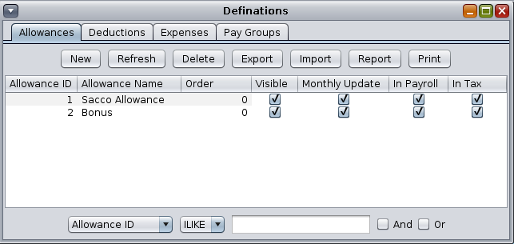

- In the window that opens, fill in the details for the new Allowance, Deduction or Expense as exemplified in the following screen-shots.

Allowances Tab: These are any amounts paid to an employee over and above their normal salary.

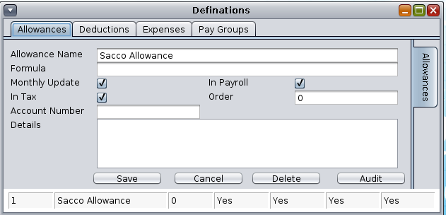

Deductions Tab: These are deductibles pertaining to the employee.

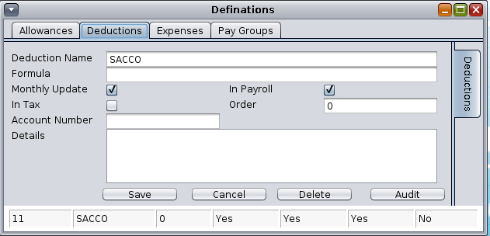

Expenses Tab: These are costs incurred which are not directly tied to an employee's salary.

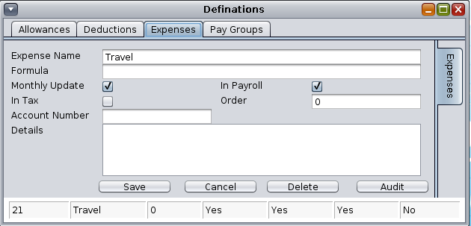

FIELD | DEFINITION
Allowance/Deduction/Expense Name | Descriptive name for the category.
Formula | Calculation needed to generate the item's amount.
Monthly Update | Check this box if you want the item calculated every month
In Payroll | Check this box if the item is reflected in the Payroll.
In Tax
Account Number
Details | Capture any other information concerning this item in this field

PAY GROUPS
These pay packages based on any criteria from Job Rank, skill, Education Experience and Duties.
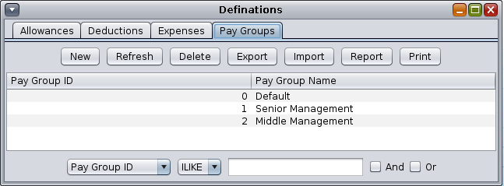

To add a new Pay Group,

- Click on Pay Groups and then click on NEW.

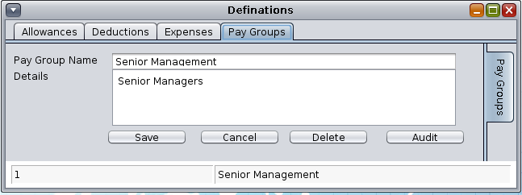
- Fill in the Name of the Pay Group and any more Detail you would like.
- Click SAVE to store the record.

STATUTORY DEDUCTIONS
These are salary deductions dictated by the laws of the country. These are determined and regulated by the state with clear guidelines on their application.

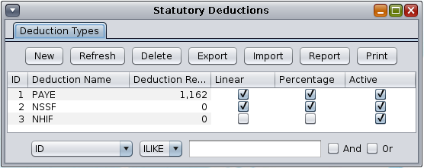

To add a new Deduction Type,
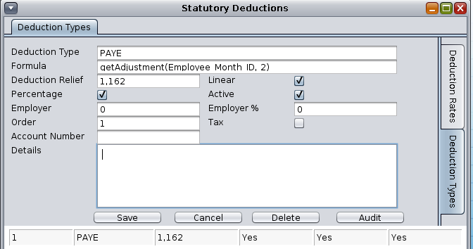

Click on the NEW button under Deduction Types

FIELD | DESCRIPTION
Deduction Type
Formula | Formula to calculate the amount due under this deduction type.
Deduction Relief | If there is a exemption in this type of deduction, fill it here.
Linear | Check this box if the deduction is of a fixed amount regardless of salary.
Percentage | Indicates whether the figures represent a percentile.
Active | Indicates whether the deduction is to be activated or not.
Employer | The amount being contributed by the employer.
Employer % | The % amount being contributed by the employer.
Order
Tax
Account Number
Details

To add Deduction Rates for each deduction Type;

- Double click to open the Deduction Type, and click on Deduction Rates to the right of the window.
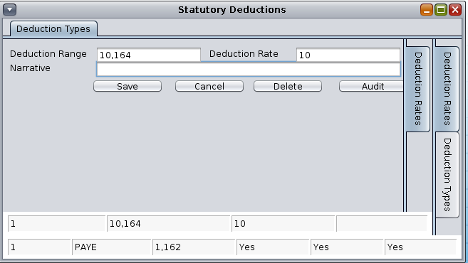

- Fill in the Deduction Range and Rate as per the statutory scheme.
- Add a Narrative (optional).
- Click SAVE to store the record.
- Repeat this process to add all the deduction ranges that fall under that deduction type.

Below is a sample of PAYE deductions scheme;

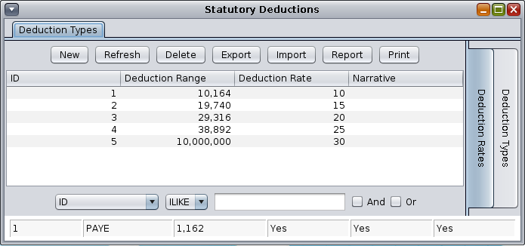

BANKS
This tab captures the banks and their branches, which receive payments on behalf of the employees. This information is first supplied by the employee upon being employed.

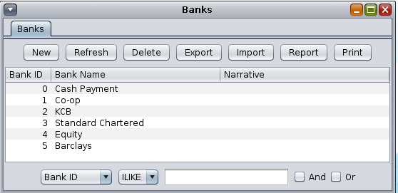

To create a new bank in the system,

- Click on NEW under the Banks tab. In the new window, fill in the Bank's Name.

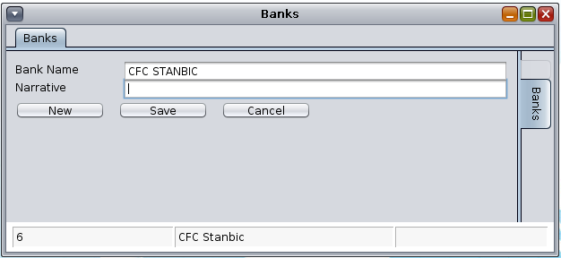

- Add a Narrative (optional).

Next, add branch or branches for this bank. To do this,
- Click on the Banks Tab to display all the banks.
- Double click on the bank you want to add branches to.
- In the window presented, fill in the Branch Name, Branch Code and a Narrative.
- Click on SAVE when done. Add all the relevant branches for each Bank.

Sample Bank creation window

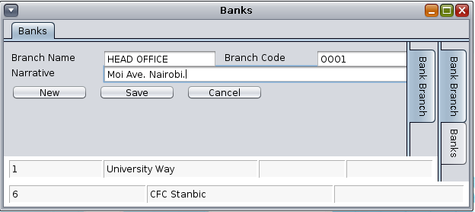

EMAIL TEMPLATES
This section allows for the creation of email templates which can be used to compose new email or used as automated reply messages.

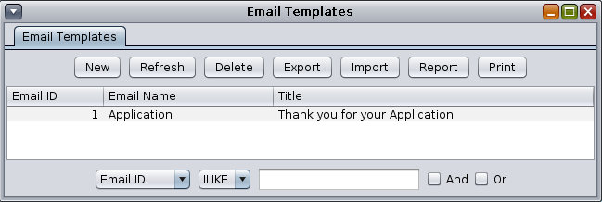
To create a new email template

- Click on the NEW button under email templates tab.
- Fill in the Email Name, Title for the email and the Details the body of the email.
- Click SAVE to store the template.

Sample email template

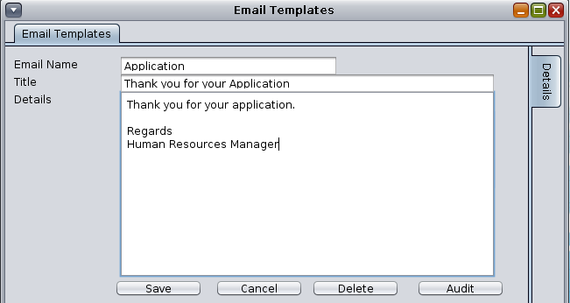
You can create as many templates as you wish to have.

ENTRIES

EMPLOYEES
This tab allows for the manipulation of Employee profiles. These profiles can either come from the Human Resources management module, or they can be created here manually.

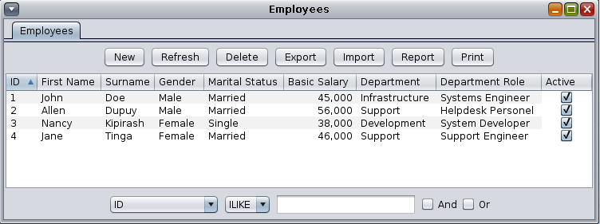
To add a new Employee;
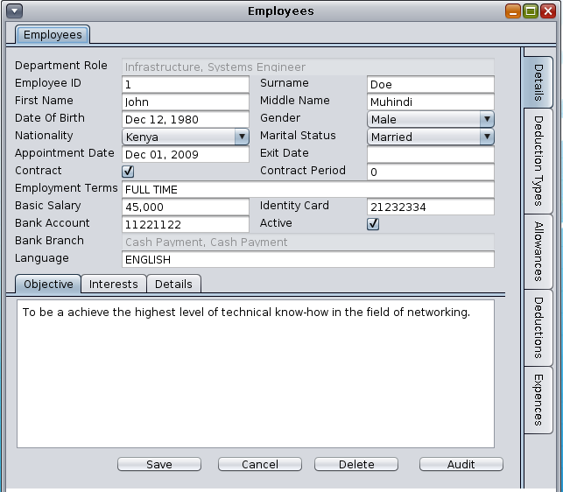

- Click NEW button under the Employees tab.
- In this window, select the Department Role based on the department the employee will fall under.
- Fill in the form with all the pertinent information regarding the employee.

- Employee ID - Staff Number
- Surname
- First Name
- Middle Name
- Date of Birth
- Gender
- ....etc

- Click on SAVE to store the record.

Adding Payroll Details for an Employee;

- In the Employees tab, double click on an employee's name.
- To the right of the screen, you have several tabs to capture payroll details.

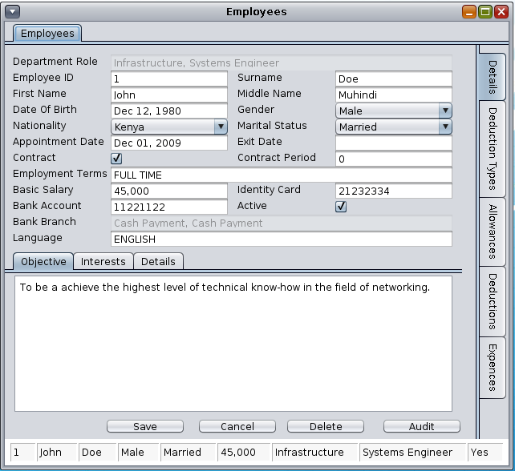

Deduction Types Tab
Use this tab to capture deduction types applicable to this employee.

- Click on the Deduction Types tab, then click the NEW button.
- Select the deduction types that apply to the employee. The statutory deduction types added earlier in the control panel of this system will be available for you to choose from.

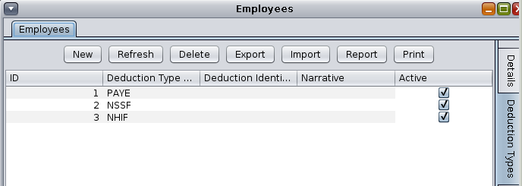

- Click on NEW and in the new window, select the Deduction Type you want to add to the employee.

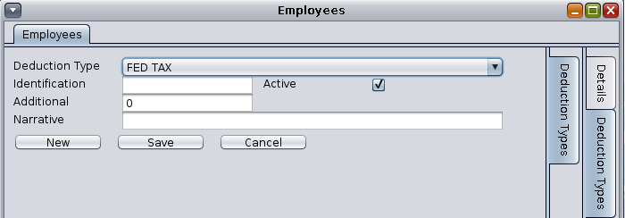

- Fill in the other fields as follows;

Identification :
Additional :
Active : Check this box to apply this deduction type to the employee.
Narrative : Additional information (optional).

Allowances Tab
Use this tab to add any Allowances to this employee.

- Click on Allowances tab, then click the NEW button,
- Select the Allowance form the list. These allowances were created in the Control Panel.
- Fill in the amount and the Final Date which is the date when the allowance stops being applicable.
- Check the Active box, add a Narrative and SAVE the record.
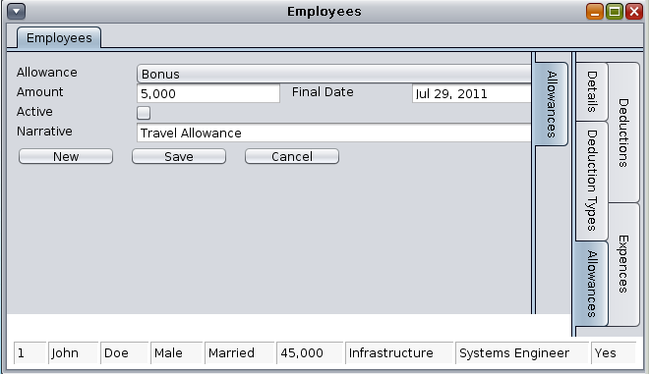
Expenses Tab
Use this tab to add any expenses charged to the employee. Click on the Expenses tab,

- Click on NEW button,
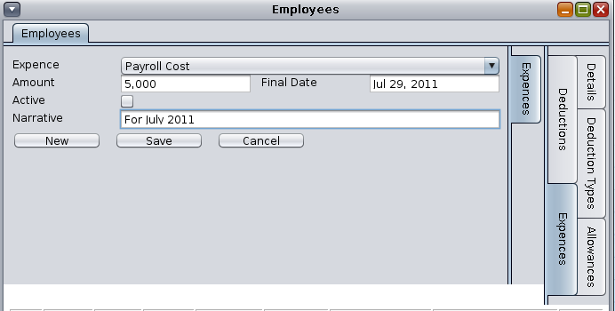

- Select the Expense from the drop-down menu.
- Key in the amount and the final date this expense applies to.
- Check the Active box to activate the expense
- Add a Narrative

MONTHLY PAYROLL
Use this tab to process monthly payroll for all the employees in the system. For each employee, the Statutory Deductions, Allowances and Deductions defined in their profile in the Employees tab of the control panel are automatically added for processing. However, one-time Allowances applicable to an employee can be added in the Advances tab.

Periods Tab
Processed payroll periods appear listed in the default window.
To calculate the monthly payroll, you need to create a period for it.

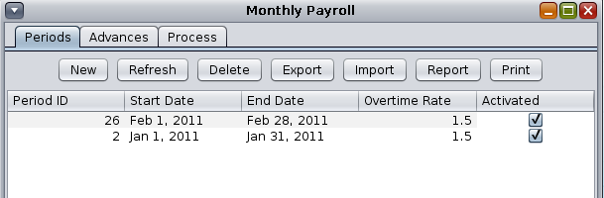

- Click on NEW button to start creating a payroll period.

FIELD NAME | DETAIL
Start Date | Date period starts
End Date | Date period ends
Overtime Rate | Overtime rate figure
Per Diem Tax Limit | Amount at which per diem tax should stop calculating.
Activated | Check this box to activate the period, or vice versa.
Closed | Check this box to Close the period to block further input. This is an administrative task.
Payroll Account
Payroll Account
Bank Address | Name of the Bank
Bank Header
Details | Additional information on the period (optional).

Sample monthly payroll period

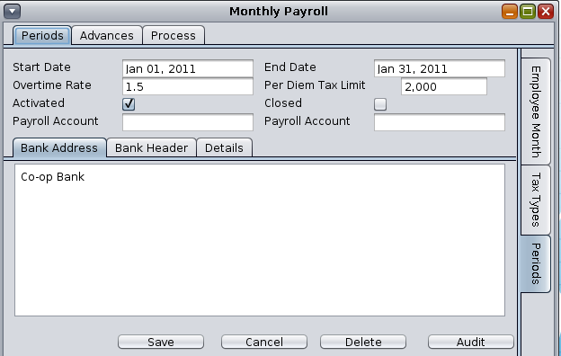
Advances Tab
Use this tab to add any new Advance payments and deductions for employees in an existing Period. Advance Payments and Deductions added here are only applicable for that period they are input under, and will not replicate to the next period.

Advances Window;

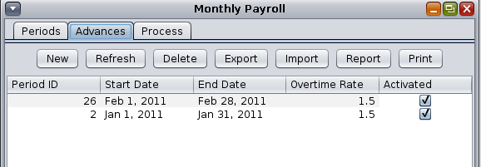

To add an Advance Payment;

- Select the Period to add the payment to. Double click on it.

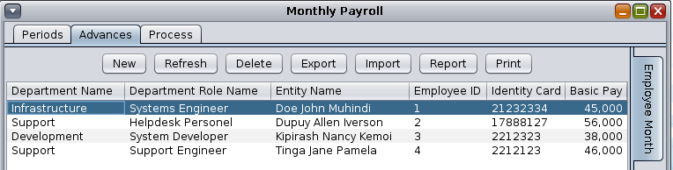

- Double click on the employee record in which the payment will be recorded.
- In the window that opens, click on NEW button. A window for Employee Advances opens up.
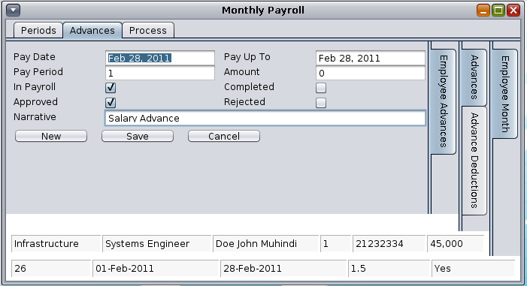

FIELD | DETAILS
PAY DATE | Date to make the payment.
PAY UP TO | Last day to pay the amount.
PAY PERIOD | Period the payment applies to. (Period ID)
AMOUNT | Amount to pay
IN PAYROLL | Whether the amount is included in the Payroll
COMPLETED | Check this box if the amount is paid.
APPROVED | Check this box if the Advance request is approved.
REJECTED | Check this box if the Advance request is rejected.
NARRATIVE | Optional free text.

- Once the form fields have been populated, click on SAVE button.
- To add a new Advance Payment for a different employee, click on the Employee Month tab to the right of the window.
- You will be presented with Employee Month window from which you select the employee. From there, proceed as instructed above in steps 1 to 4.

To add an Advance Deduction;

While still in the Advances tab, you can add any Advance deductions to any employee in the specific period you are working on.

- Select the Period to add the deduction to. Double click on it.
- To the right of the open window. Click on Advance Deductions.

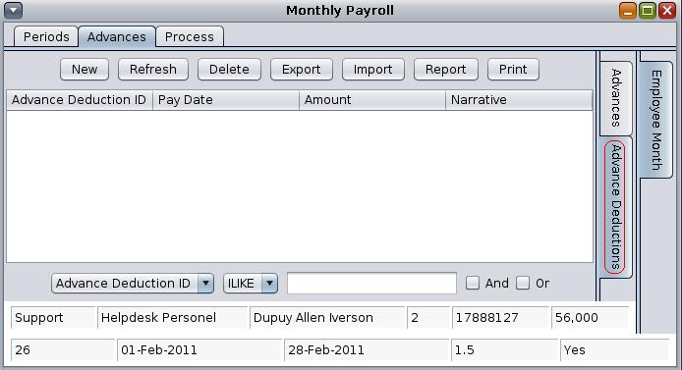

- Click on NEW button to add a new Deduction for this employee.
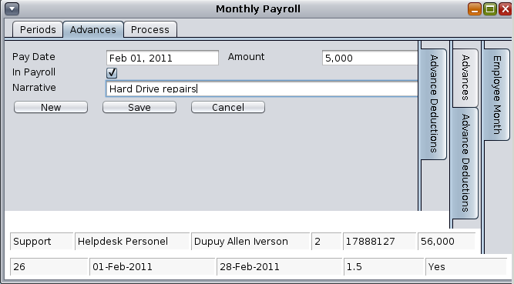

FIELD | DETAILS
PAY DATE | Date to make the deduction.
AMOUNT | Amount to deduct.
IN PAYROLL | Whether the amount is deducted in the Payroll
NARRATIVE | Optional free text.

PROCESS TAB
…............
…...........
…..........

MONTHLY ADJUSTMENTS

Use this tab to make amendments to the payroll period entries already made. You can add new Advance Payments, Deductions, Tax types, Allowances, Expenses, Overtime and Per Diem entries for an employee.

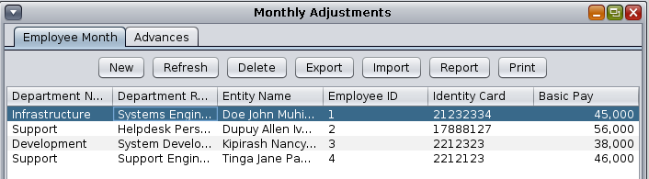
To make adjustments, double click on the employee concerned.

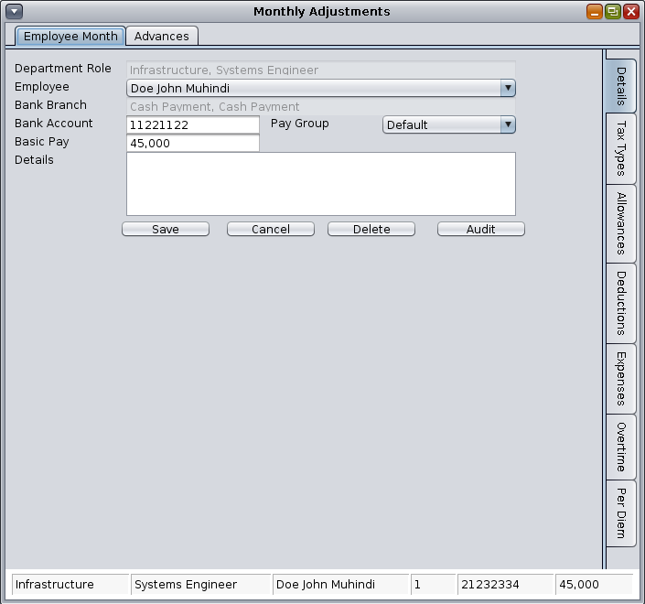

To the right of the window, you find different tabs for the various categories of packages that the payroll carries.

FIELD | DETAILS
Tax Types | Mandatory tax types
Allowances | Examples such as SACCO and bonuses.
Deductions | Examples such as HELB, rent.
Expenses | Examples such as Medical, Travel, Insurance
Overtime | Overtime
Per Diem | Per diem

To adjust each of the categories above, first, select the employee whose information you want to adjust.

- Double click on that employee's name.
- Next, click on the appropriate tab on the right hand side of the window.
- Edit an existing record, which will be displayed in the screen, or create a new entry.

Examples
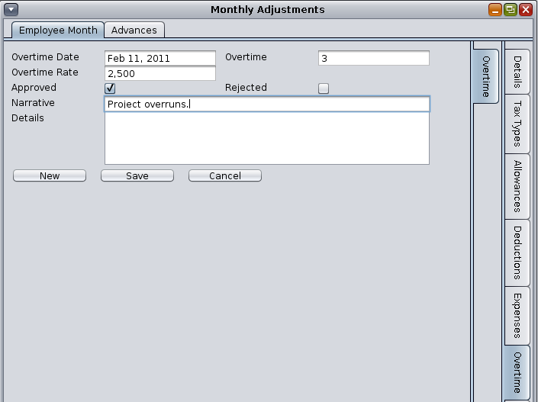

Overtime rate – rate at which overtime is compensated, e.g. rate per hour
Overtime – number of hours/days of overtime to be compensated.

Per Diem Screen
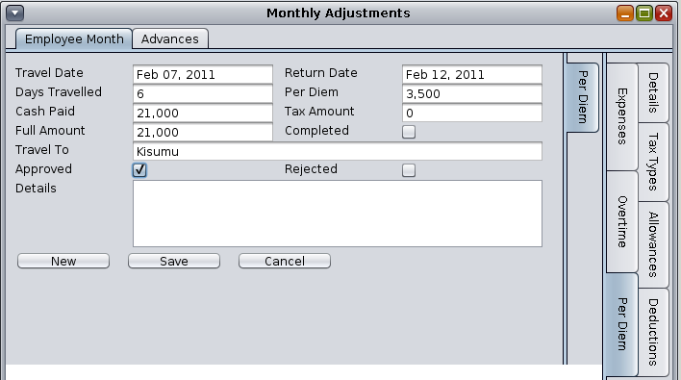

REPORTS

