Human resource management (HRM) issues have been major concern for managers at all levels, because they all meet their goals through the efforts of others, which require the effective and efficient management of people

Efficiency in any organization begins at the point of impact where a worker performs a job. Employees who have the right skills, knowledge, and abilities can have an impact on your company’s bottom line. Unfortunately, even good employees don’t manage themselves. It takes fast, reliable information and a system behind it to let your people have the greatest positive impact for them, for you, and for your organization.

**OpenBravo Human Resource Management System** (**OBHRMS**) delivers a comprehensive platform and robust functionality that helps your organization execute all four Human Capital Management (HCM) strategies:

* ***Comply***: Managing core HR data and processes, payroll, benefits, and legislative/regulatory compliance.
* ***Automate***: Saving cost and time with comprehensive, work-flow driven employee and manager self-service.
* ***Measure***: Providing metrics and analytical tools to stakeholders to deliver information and determine the value of HR program investments.
* ***Align***: Offering flexible programs designed to increase workforce value through a broad range of development, performance management, and learning applications.

The vast array of HRM activities for example, planning, recruiting, selection, and training just to mention but a few, place enormous responsibilities on supervisors and managers alike. Highlights include;

* analyzing jobs
* planning labour needs
* selecting employees
* training employees
* managing compensation
* communicating (which includes counseling and disciplining)
* ensuring fair treatment
* appraising performance
* ensuring employee health and safety
* handling complains and grievances
* Other legislation affecting the workplace.

Regardless of field of expertise, learning about employee rights, employer responsibilities, and effective HRM practices may provide all managers with knowledge that enables them to perform more effectively.

**OpenBravo HMRS**

Contains the following interfaces;

**News Admin**

**Organization**

This is where you configure the organization's profile in to the system.

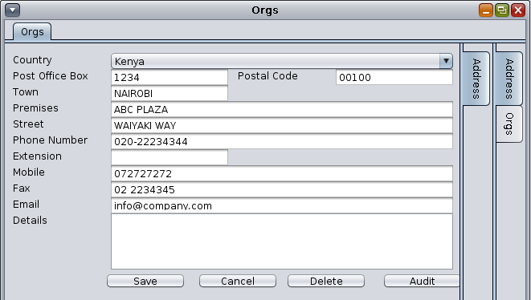

The screen above shows the information captured concerning the organization. The Tabs on the right of the screen give access to different sections of the Organization's profile to access more information.

* Addresses - Displays the contact details of the organization.
* Orgs - Displays and allows capture of Organization's PIN and Bank details. This is also the window where you set the default organization for the system.

**Banks**:

This interface is used to set up the various banks used by the organization to pay creditors.

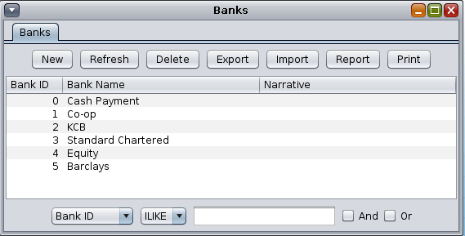

The details captured per each bank are the Bank Name and a Narrative. This interface can be used to add new banks, edit or delete Banks.

**Departments**

This interface allows for the creation of various departments for the organization. Details captured include Department ID, Parent Department, Department Name, Description, Duties, Reports and Details.

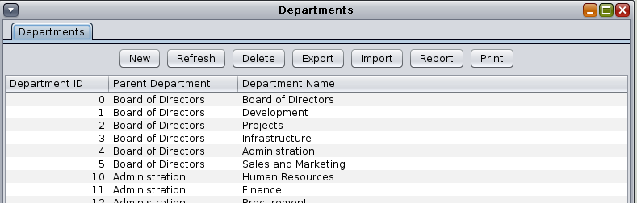

Each Department has roles for the staff within it. Each role has details defining who they are going to be Reporting To, as well as the Department Role, Duties, Requirement, Measures and Details.

Sample department roles created.

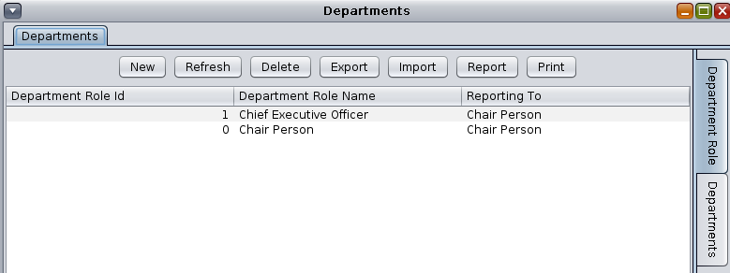

*Departmental Role d*efinition;

Below is an example of how to define Departmental Role of a Chief Executive Officer.

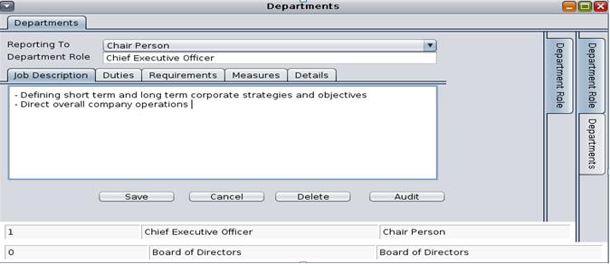

**Applicant**

This window captures the details of all job applicants. It is here that personal details from the applicants' CV are captured. The applicant's bio-data, their Objectives and Interests are filled in here.

Applicant Details

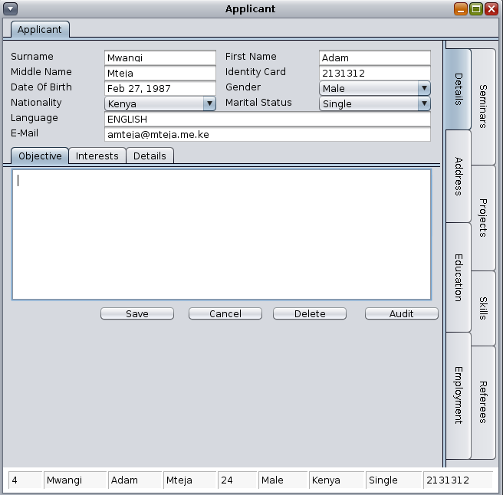

The tabs on the right hand side of the window allow or the input of further details such as the Applicant's

* *Education* *Background* - Academic background and achievements
* *Employment* - Employment history
* *Seminars* - Seminars attended
* *Projects* - Projects undertaken.
* *Skills* - Skill type and level acquired and the mode of acquisition.
* *Referees* - Contacts for referees.

**Employees**

This window captures details about each employee in the organization.

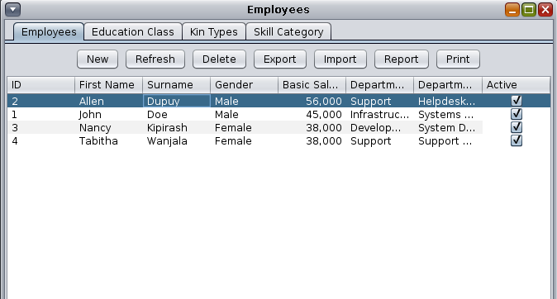

The information is categorized into;

*Employees*:

This tab contains the employee's bio-data, remuneration terms Department and Department Role. It also captures the employee's bank account details, Education background, next of Kin details and skill Category and more.

When you double click on the employee's name (or click NEW), the resulting window has tabs to the right to capture more data such as Employment history, Seminars attended, Projects and Referees.

All this information goes towards building the employees electronic C.V.

*Education Class:*

This tab allows for the creation of Educational Classifications. These classifications are based on the academic levels that exist, for example Primary School, Secondary, Certificate Level, Diploma, Higher Diploma, Under Graduate and Post Graduate.

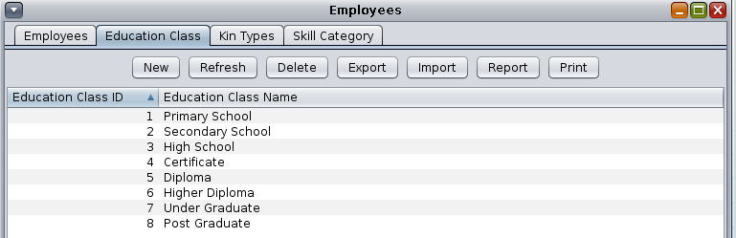

To add a new Class, click on the NEW button to get a new window;

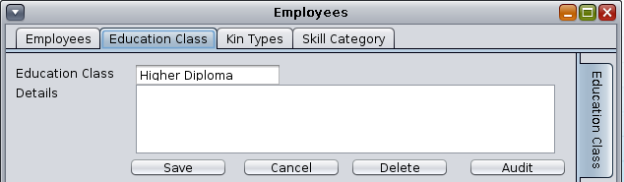

* Type the Education Class name and details for it. Click SAVE to store the record.

*Kin Types:*

This tab allows you to define possible next of kin entities. These will be used in selecting the next of Kin for employees.

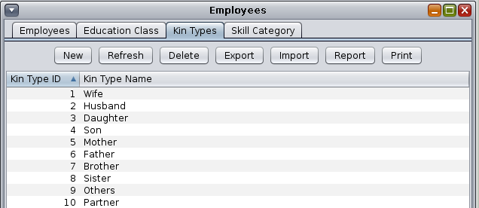

To add a New Kin, click on the NEW button

Type the Kin Type Name and details. Hit SAVE to store the record.

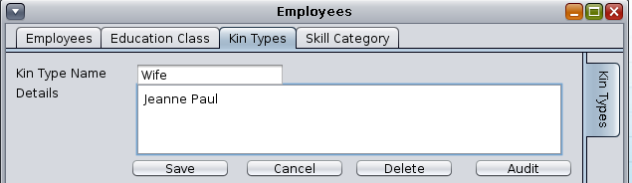

*Skill Category:*

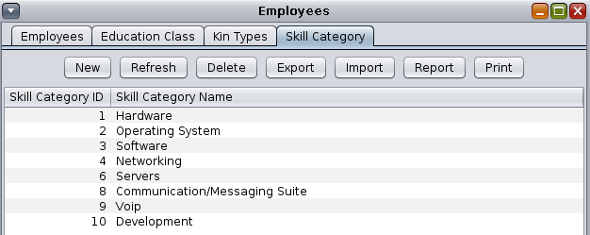

This tab allows you to create categories to classify the different skill-levels possible for an employee to have.

To add a new Skill Category, click on the NEW button.

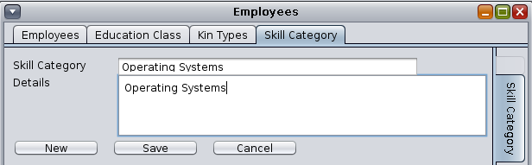

* Input the Skill Category Name and Detail before clicking SAVE to store the category.
* In the Skill Category Tab, double click on the category you just created to add the Skill Types necessary for this category of Skill.

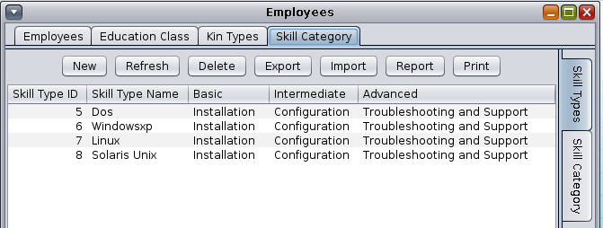

* Click on NEW

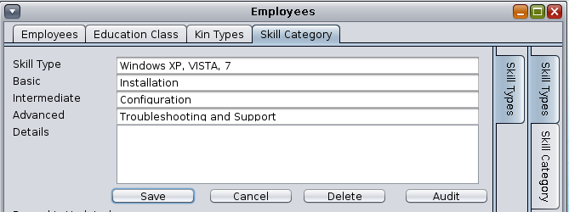

* Type the Skill Type and the skill required at the Basic, Intermediate and Advanced level.
* Click on SAVE when done.

**ADD a NEW Employee:**

1. Click on the NEW button to get the following window.

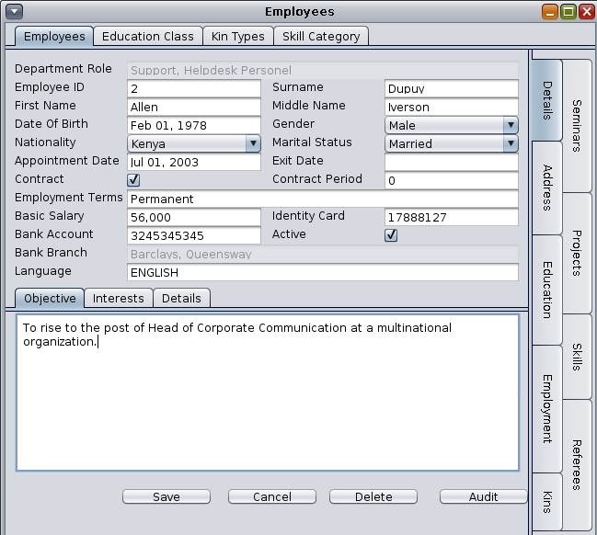

1. In this window, select the Department Role based on the department the employee will fall under.
2. Fill in the form with all the pertinent information regarding the employee.

* Employee ID - Staff Number
* Surname
* First Name
* Middle Name
* Date of Birth
* Gender

….etc

To the right of the screen, you have several tabs to further capture more details about the employee.

*Address Tab*

Use this tab to capture the employee's contact details. Once you click on it, click on the NEW button to insert a new contact.

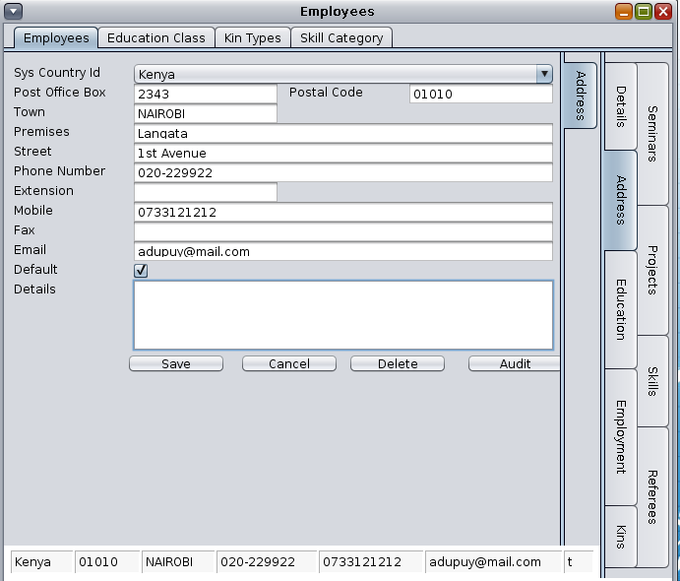

* Once you select the System Country ID for the employee, start filling in the form with the relevant information and the click on the SAVE button. If you check the Default box, the address becomes the default contact for that employee.
* The employee can have multiple addresses, all visible in the Address tab. To edit any address, double click on it in the Address Tab.

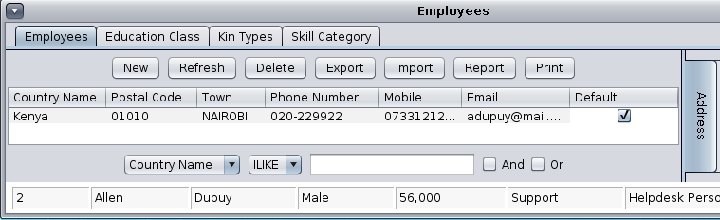

*Education*

Use this tab to capture the employee's academic information. Click on Education then click NEW.

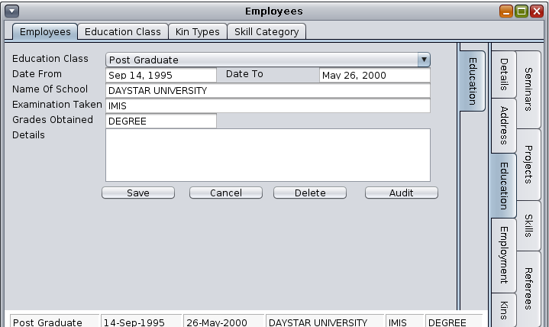

* Once you have selected the Education Class (Primary, Secondary, Diploma, etc.), fill in the details for each particular education class based on the employee's certificates. An example is provided above *Fig.10*
* Click SAVE when done.
* The employee Education profile should list all their qualifications for different classes. See

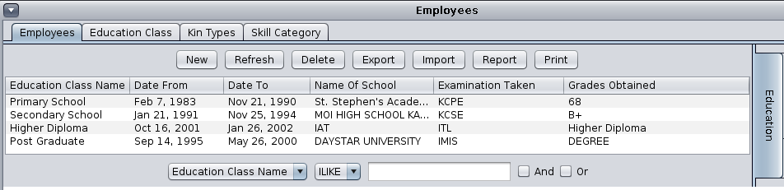

*Employment*

Use this tab to capture the employee's employment history. Click on Employment tab to the right of the screen, and then click NEW.

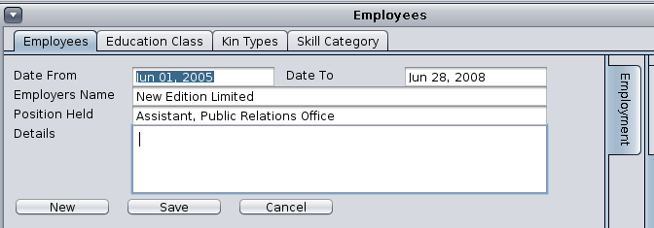

* Fill in the details as in the example above and click on SAVE. Depending on how many places the employee has worked before and submitted in their C.V., create a new record for each company worked for.

*Kins*

Use this tab to capture the employee's next of kin details. Click on Kin tab to the right of the screen then click on NEW.

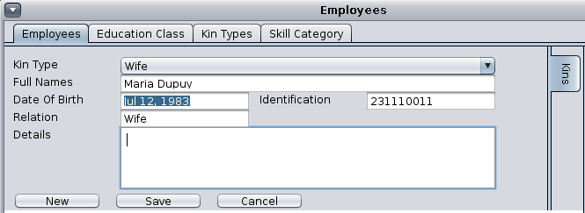

* Fill in the details as in the example above and click on SAVE.
* Multiple kin can be captured in this window, click NEW to add a new kin record.

*Seminars*

Use this tab to capture details about any seminars/trainings that the employee has attended before joining your organization. Click on Seminars Tab to the right the screen and click on NEW.

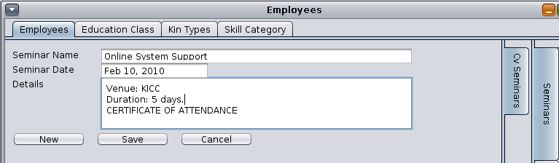

* Fill in the details as in the example above and click on SAVE.
* Multiple records can be captured in this window, click NEW to add new records and then SAVE.

*Projects*

Use this tab to capture details about any projects the employee is/has been involved in.

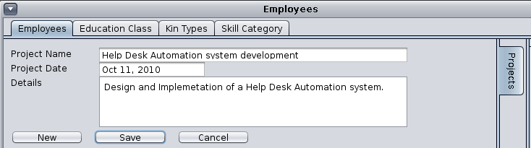

* Fill in the details as in the example above and click on SAVE. Capture these details as soon as the employee has undertaken the project.
* Multiple Projects records can be captured in this window, click NEW to add new records and then SAVE.

*Skills*

Use this tab to capture the employee's skills set. Click on the Skills Tab to the right of the screen and then click NEW to start inputting the data.

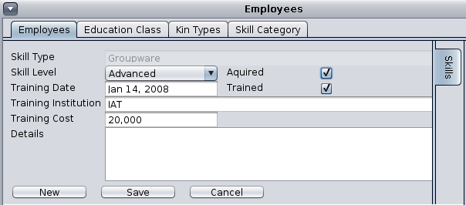

* Select the Skill Type and the relevant Skill Level. Skill types should be in line with the organization's existing skill categories. The employee has to have a skill that the organization requires.
* The Skill Levels are Basic, Intermediate and Advanced.
* If the skill was acquired or trained, specify that too.
* Once you complete the form, SAVE it and add a new Skill by clicking on NEW.

*Referees*

Use this tab to capture the employee's referees as submitted in his/her C.V. Click on the Referees tab to the right of the screen, and click on NEW.

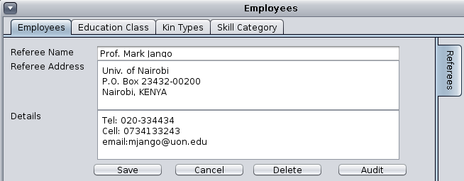

Fill the form to resemble the example in the figure above. When done, click the SAVE button.

**Casuals**

This window allows you to capture details concerning staff working on casual-contract basis.

*Casual Application*

Use this tab to add casual worker information.

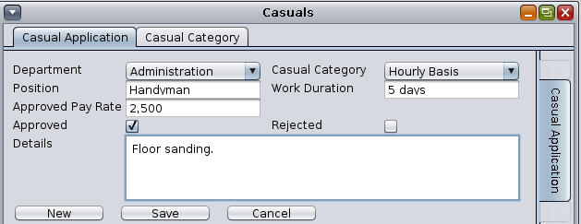

* Define the Department the employee will be in, the position they are filling, the category of casual labour they belong to as well as the wage and work duration.
* Stipulate whether the application is Accepted or Rejected.

*Casual Category*

Use this tab to create different categories for classifying Casual employees.

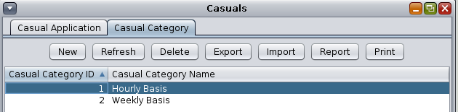

* Click NEW to add a new category.
* Fill in the casual category name and details. Click SAVE to store the record.

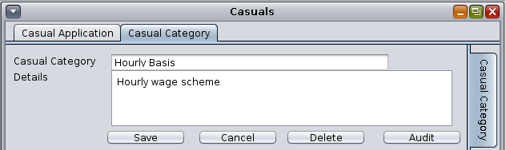

**Leave**

This module is used to process leave for employees of the company.

There are two tabs in the Leave window, namely Employees and Leave Types:

*Employees*

This tab gives a listing of the employees in the system.

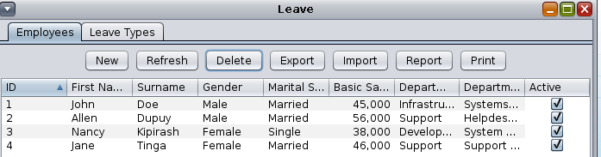

*Leave Types*

This tab allows you to define the different types of leave the company recognizes.

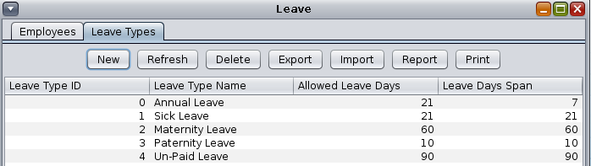

To add a new leave type, click on NEW and fill in the form presented.

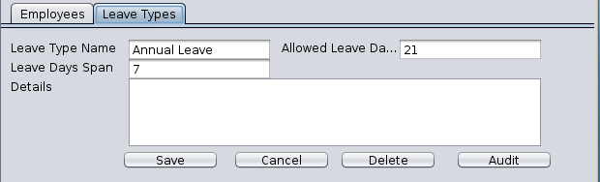

Save the form to store the record.

**Leave Application**

1. To apply for leave, open the staff profile by double clicking on the staff member's record row.
2. In the window that opens, click NEW

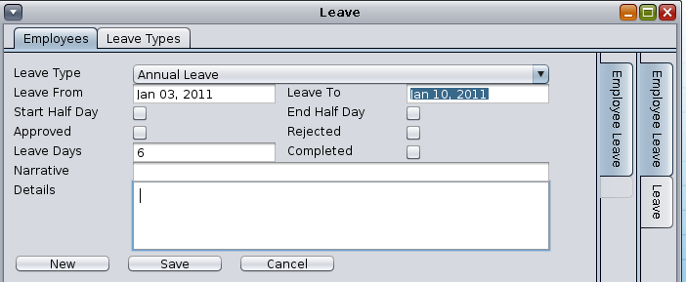

1. Fill in the form appropriately.
2. If the leave commences and terminates in the middle of specific days, then use the Start Half Day and End Half Day check boxes.
3. Set the leave status, whether Approved, Rejected and whether it is completed.
4. Fill in the leave days.
5. Give a narrative and some optional details.
6. Click SAVE.

If you double click on the employee record again, you find the leave application listed there.

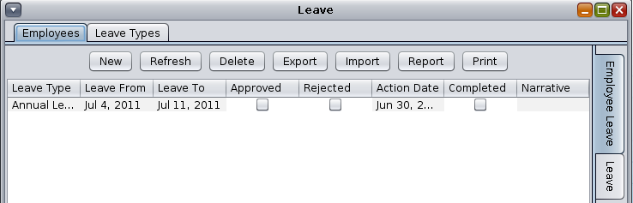

To the right of the window, you have the Employee Leave Tab, and the Leave Tab. The Leave tab displays a report format of the leave.

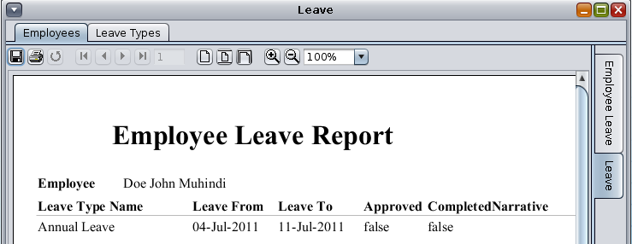

**Leave Approval**

This window is used to process incoming leave applications, by approving or rejecting.

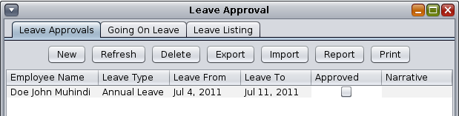

1. The window displays all the applications submitted. To process the applications, double click the record to open it.
2. Check the appropriate box to approve or reject the application

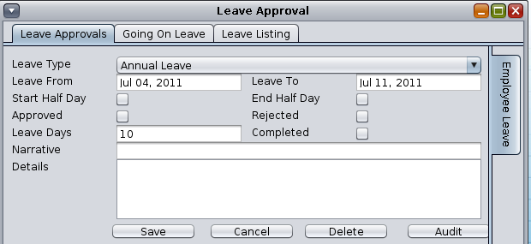

**Intake**

This tab is used to process job intakes for vacancies created through this system. When recruiting new staff to fill in vacant positions in the organization, you can track the recruitment process through this section of the Administration module. The first step is to create the open position in the system. The next step involves assigning applicants to the various positions they applied for.

To capture vacant position(s) into the system;

1. Click on the ***Intake*** link

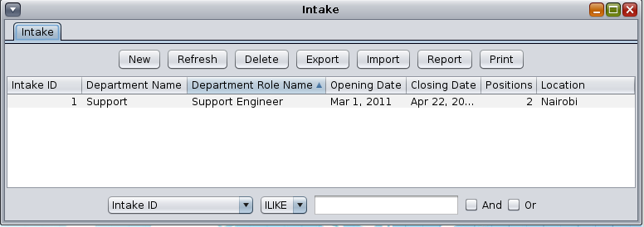

1. In the Intake window, click on NEW button to create a new vacancy

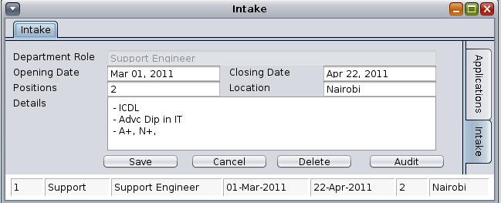

1. In the Intake window, select the Department Role and fill in the fields as follows;

|  |  |
| --- | --- |
| ***Opening Date:*** | Date application for the position opens up. |
| ***Closing* *Date*:** | Date application for the position closes. |
| ***Positions*:** | Number of positions vacant for that role. |
| ***Location*:** | Where branches exist, this field identifies which location has the vacancy. |
| ***Details*:** | Further details concerning the vacancy announcement. |

Once the Vacancy has been created in the system, populate it with any applications for it that come into the organization. To do this

1. Open the Intake window and double click on the Intake in the list.

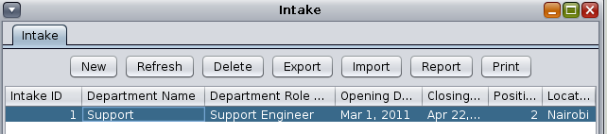

1. In the window that opens up, click NEW button to add new applicants from the Applications Module.

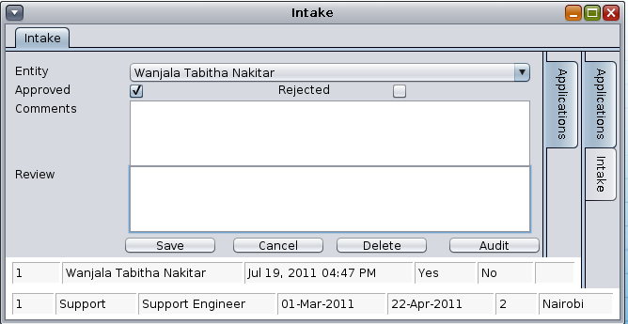

1. Fill in the form as follows;

|  |  |
| --- | --- |
| ***Entity:*** | Select the applicant from the list of applicants. |
| ***Approve of Rejected*:** | Check the box for either Approved or Rejected |
| ***Comments*:** | Free text |
| ***Review*:** | Free text |

1. Click SAVE to save that application under that vacancy.
2. Repeat the process for all the applications received for the vacancies applied to.

**Internships**

This section is used to process internship programs in the organization. An internship is a work-related learning experience for individuals who wish to develop hands on work experience in a certain occupational field. Most internships are temporary assignments that last approximately three months up to a year. The positions under internship are allocated to interns and not employees.

To create new Internship position;

1. Click on the Internship link. In this window, click on the NEW button.

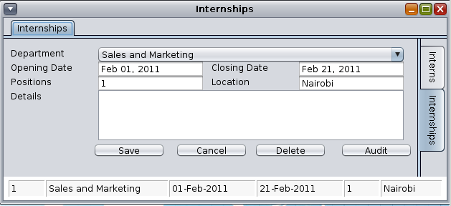

1. Fill in the form fields with details.

|  |  |
| --- | --- |
| ***Department:*** | Select the Department under which the program falls. |
| ***Opening Date:*** | Date application for the position opens up. |
| ***Closing* *Date*:** | Date application for the position closes. |
| ***Positions*:** | Number of positions vacant for that role. |
| ***Location*:** | Where branches exist, this field identifies which location has the vacancy. |
| ***Details*:** | Further details concerning the vacancy announcement. |

1. Click SAVE button to save the record.

Next, allocate Intern(s) to the particular program created. To do this, click on the Internship tab at the top of the window.

1. Double click on the program created.

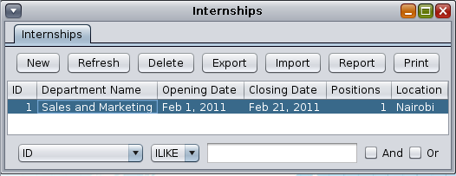

1. Once open, click on the NEW button to add an intern into the program.

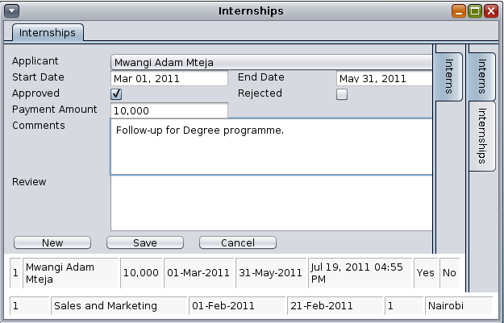

1. Select the Applicant from the list of Applicants.
2. Fill in the form after which you click on SAVE to store the record.

**Job Review**

This module is used process job reviews for employees. It keeps track of job review results done for each employee over time.

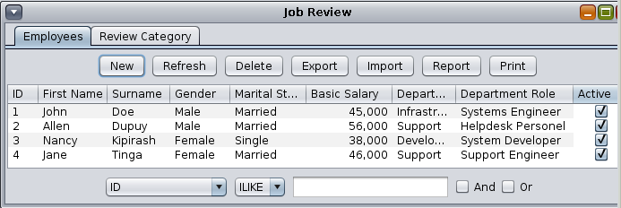

The Job review window opens with a view of all the employees within the organization. Processing a job review begins by you selecting the employee record first.

To create a new review;

1. Double click on the employee’s name and in the window that opens up, click on the, NEW button.

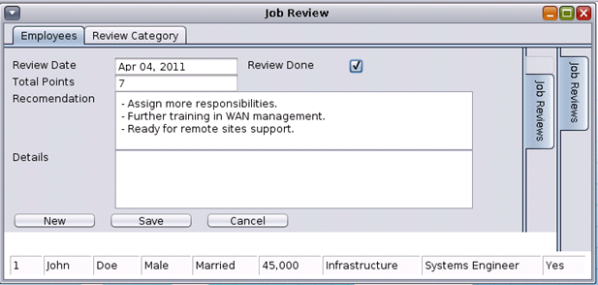

1. Fill in the form as follows;

Review Date: Date the review is done.

Review Done: Whether the review has been done or not.

Total Points: Score earned after review. This is a sum of all Review Categories’ scores

Recommendation: Free text concerning any recommendations.

Details: Free text on any further details.

1. Click SAVE button to save the record.

*Review Category*

These are different variations or groups of Reviews you can have for your organization. Job reviews and appraisals can be classified into the following samples, Technical Knowledge & Skills, Productivity, Initiative, Communication & Teamwork, Decision-Making and Problem Solving, Leadership Qualities, etc.

To create a new review category,

1. Click on Review Category tab at the top of the Job Review window.

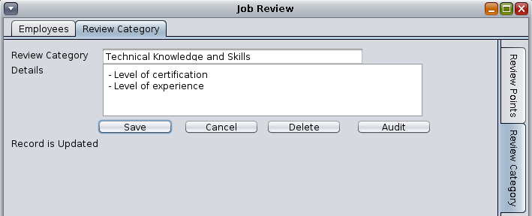

1. Click on SAVE to store the category.

*Review Points*

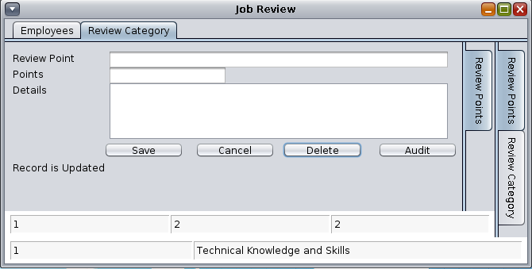

Review Point:

Points: Highest score for this Review Category.

Details: Free text for any further information.

**Arbitration**

Arbitration is a legal technique for the resolution of disputes outside the courts, where the parties to a dispute refer it to one or more persons (the "arbitrators", "arbiters" or "arbitral tribunal"), by whose decision (the "award") they agree to be bound. It is a settlement technique in which a third party reviews the case and imposes a decision that is legally binding for both sides.

This module is used to keep track of these cases and their outcomes for future reference as well as follow-up and enforcement of judgments passed.

The default screen for the Arbitration module;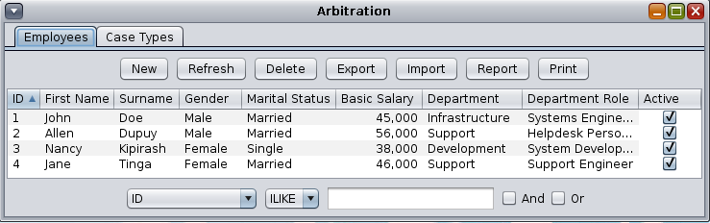

To record arbitration, first you need to create Case Types to group cases. To create a Case Type, click on the Case Type Tab.

Case types

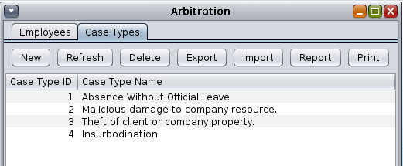

1. Click on the NEW button to create a new case type.
2. In the window that loads, fill in the details for the case type as demonstrated below.

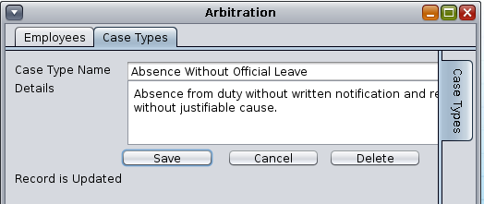

1. Click on SAVE to store the record.

To record an arbitration case, go back to the Arbitration window;

1. Select the employee involved by double clicking on their record in the list.
2. In the window that loads, fill in the details of the case as in the example below,

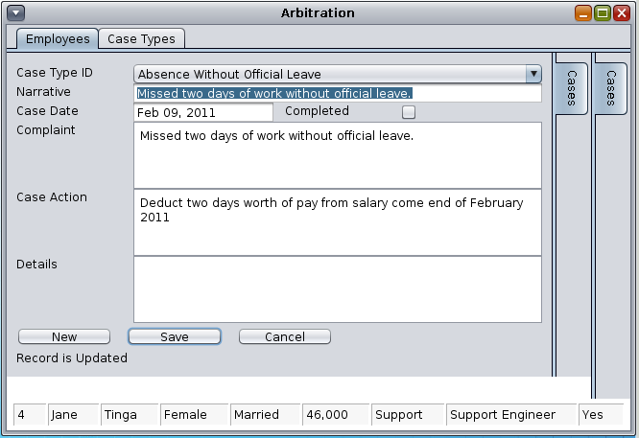

1. Select the Case ID from the list of Case Types listed.
2. Fill in a *Narrative* and the *Case date*.
3. Once the case has been resolved, check the COMPLETED check box.
4. *Complaint*: Fill this field with details of the nature of the complaint.
5. *Case* *Action*: Captures the resolution passed on the matter.
6. *Details*: Further details pertaining to the case can be filled in here.
7. Click on the SAVE button to store the record.

Whenever you access an employee’s record the Arbitration link, you gain access to their history of arbitrations.

Double click on that employee’s record and a new window opens up displaying any arbitration cases in their past.

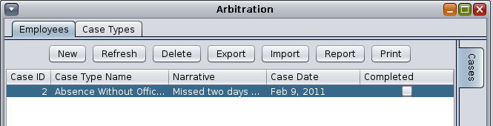

**REPORTS**

**BANKS**

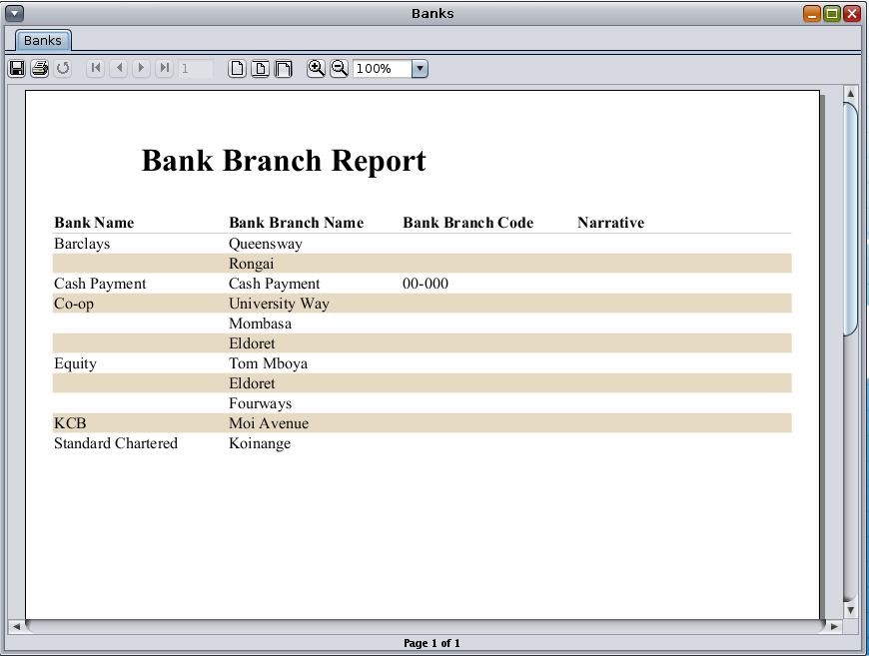

**DEPARTMENTS**

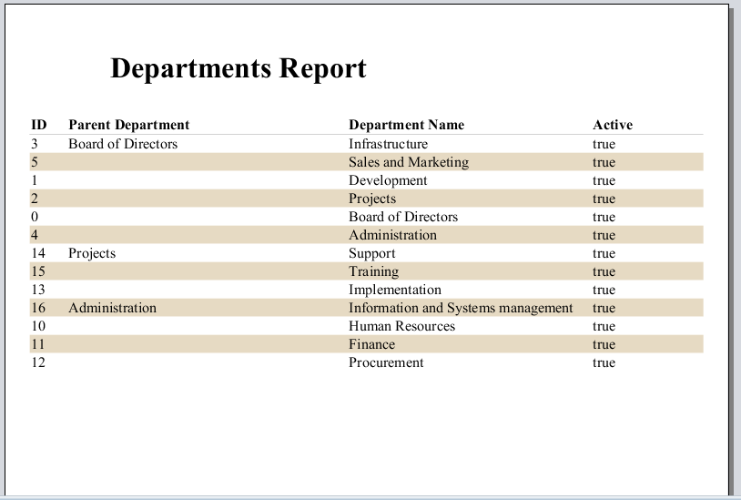

**Department Roles**

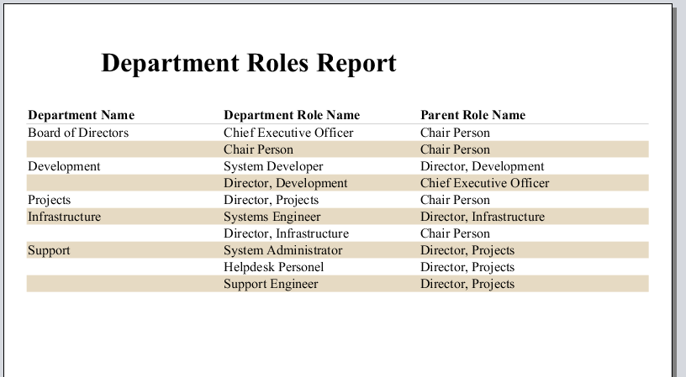

**EMPLOYEE LIST**

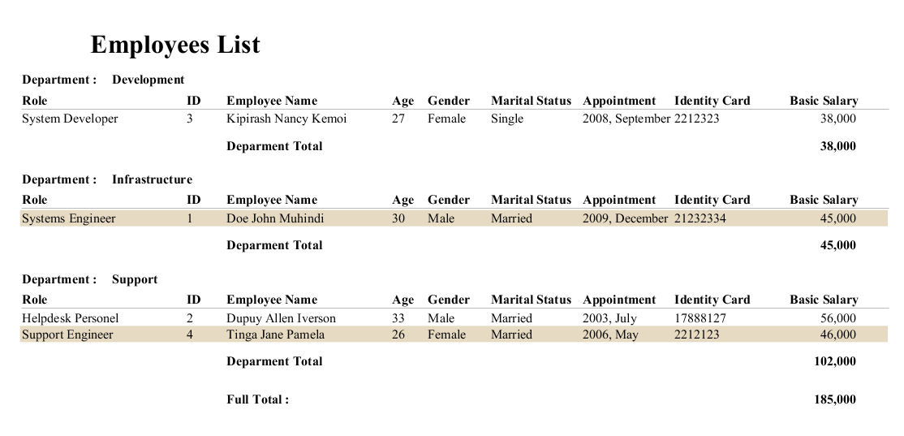

**CV EMPLOYEES**

…narrative...

